**CTF Challenge: Blue Team Fundamentals**

## 

## 

## 

## **Blue Team Fundamentals: Defenders of the Digital Realm**

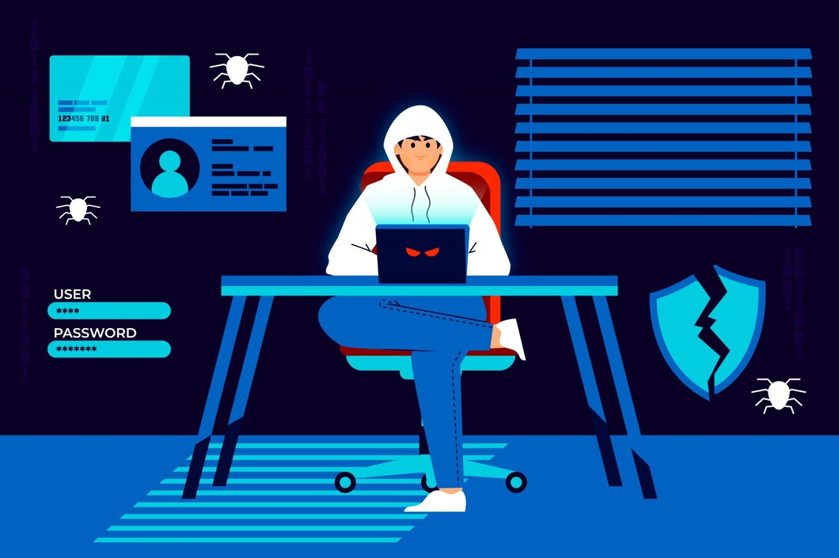

Blue teams are the cybersecurity professionals responsible for protecting an organization's systems, networks, and data from cyberattacks. They act as the first line of defense, constantly monitoring for threats, detecting suspicious activity, and responding to security incidents. Here's a breakdown of essential Blue Team concepts:

**Core Responsibilities:**

* **Security Monitoring:** Blue teams closely monitor network activity, system logs, and security alerts to identify potential threats and suspicious behavior. This may involve Security Information and Event Management (SIEM) tools that aggregate data from various sources for analysis.
* **Incident Response:** When a security incident occurs (e.g., data breach, malware infection), blue teams follow established procedures to contain the damage, eradicate the threat, and restore affected systems.
* **Vulnerability Management:** Blue teams play a crucial role in identifying, prioritizing, and patching vulnerabilities in systems and applications to minimize the attack surface and exploitation opportunities.
* **Security Awareness and Training:** Educating employees about cybersecurity best practices and phishing attempts is vital to minimize human error as a security risk. Blue teams may be involved in developing and delivering security awareness training programs.
* **Security Policy Enforcement:** Blue teams ensure adherence to organizational security policies that define acceptable behavior and security protocols for users and systems.

**Blue Team Skills and Tools:**

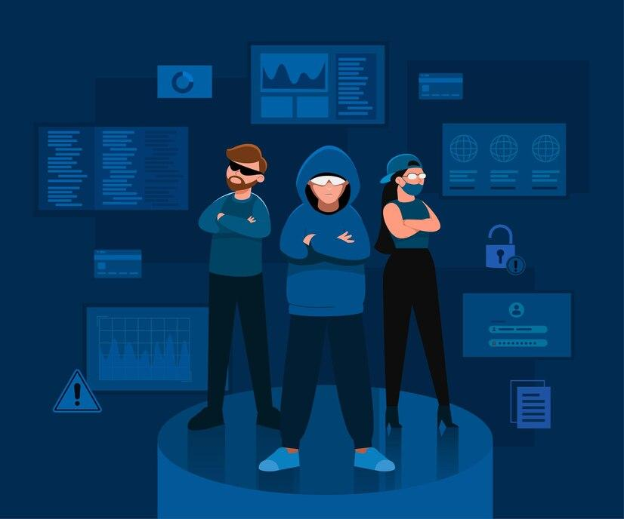

* **Security Analysis:** The ability to analyze security logs, network traffic, and forensic data to identify and understand threats.
* **Incident Response Planning:** Developing and maintaining a well-defined incident response plan that outlines roles, responsibilities, and procedures for handling security incidents.
* **Vulnerability Assessment and Patch Management:** Proficiency in tools and techniques to identify vulnerabilities and ensure timely patching of critical systems.
* **Digital Forensics:** The ability to collect, analyze, and preserve digital evidence in case of a security incident.
* **Security Automation:** Utilizing tools and scripts to automate repetitive tasks and improve efficiency in security operations.

**Collaboration with Red Teams:**

* Blue teams work collaboratively with red teams to strengthen the organization's overall security posture.
* Red team exercises simulate real-world attacks, helping blue teams test their incident response capabilities and identify areas for improvement in their security controls.

# **Capture the Flag (CTF) Challenges**

**Flag 1. Blue teams are responsible for monitoring network activity and security alerts to identify potential threats. What general term describes this ongoing process?**

Answer: Monitoring

**Flag 2. When a security breach occurs, blue teams follow established procedures to contain the damage and eradicate the threat. This overall process is called what?**

Answer: Response

**Flag 3. Patching vulnerabilities in systems and applications is a crucial Blue Team responsibility to minimize what?**

Answer: Attack Surface

**Flag 4. Educating employees about cybersecurity best practices helps reduce the risk of human error. Blue Teams may be involved in what kind of training for employees?**

Answer: Security/Awareness

**Flag 5. Security Information and Event Management (SIEM) tools are helpful for Blue Teams because they aggregate data from various sources for analysis. What type of data might SIEM tools analyze?**

Answer: Logs/Traffic